An Improved Acquisition Algorithm for GPS Signals

Full Name1, Full Name2... and Full Name1, 2

1. The Department, Faculty and Name of Institute, City, Zip Code, Country

2. The Department, Faculty and Name of Institute, City, Zip Code, Country

**Abstract:** In GNSS software receiver, the performance of the software receiver such as acquisition time is of importance. Conventional GNSS signal acquisition techniques are considered inadequate in real-time software receiver. In this paper a traditional circular correlation algorithm is analyzed and then we improve this traditional algorithm on the basis of analysis on power spectrum of the local generated code. In terms of analysis, the power spectrum of the local generated code is asymmetrical. So only the first-half spectrum lines were used in improved circular correlation algorithm. The experimental results show that the speed of the improved circular correlation algorithm nearly doubles that of traditional circular correlation algorithm and the improved algorithm has good acquisition performance. The improved circular correlation algorithm is more suitable than the traditional one in software receiver.

**Key words:** GPS, signal acquisition, signal power spectrum.

1. Introduction[1]

GPS software receiver research has drawn more and more attention in recent years due to its numerous advantages [1]. Many research works focus on base-band signal processing in the software receivers. In signal processing algorithm, the speed of acquisition is very important.

There are several acquisition algorithms for GPS signals introduced in recent years. These algorithms are often implemented in time domain and frequency domain. Among these algorithms, serial search acquisition is a traditional method for acquisition in CDMA system, but it is time-consuming and performed through hardware in the time domain. In contrast, the conventional circular correlation algorithm increases the speed of acquisition by transforming correlation calculation into the frequency domain through DFT calculation [2-3].

In this paper, we analyze the characteristics of signal power spectrum of the local generated code in the frequency domain, and then improve the circular correlation algorithm. The experimental results prove that the improved circular correlation algorithm is more suitable in the software receiver. The paper is organized as follows: Section 2 discusses the traditional acquisition. Section 3 introduces the improved acquisition. Section 4 is fine frequency estimation. Section 5 introduces signal tracking. Section 6 presents results and discussions. Section 7 gives conclusions. Section 8 presents future work.

2. Traditional Acquisition

The purpose of acquisition is to determine coarse values of carrier frequency and code phase of the satellite signals [3]. Fig. 1 gives structure of conventional circular correlation algorithm.

As seen from the above diagram, the intermediate frequency signal can be written as .The local signal  can be written as Eq. (1):

 (1)

Where  represents the C/A code,  is the intermediate frequency,  is the sample time interval.

The DFT of  with length  is calculated as Eq. (2):

 (2)

Multiplication of  and  can be written as Eq. (3):

 (3)

At last, the result in time domain can be written as Eq. (4):

 (4)

The absolute value of  can be written as . The  andcan be obtained by finding out the maximum of .

In our implementation, conventional circular correlation algorithm output of a visible satellite is shown as follow (see Fig. 2):

And the execution time of the method of acquiring one satellite is 0.47s. The results prove that circular correlation acquisition is suitable for software receiver. But the algorithm acquiring 32 satellites needs 15s and it is not real-time. So the traditional algorithm should be improved to speed up. There are two factors affecting the speed of acquisition, which are DFT calculation and size of two-dimension search space.

3. Improved Acquisition

In terms of our analysis on the local generated code , the spectrum is asymmetrical, which is shown in Fig. 3. It is seen that the information is mainly contained in the first-half spectrum lines. The second-half spectrum lines contain very little information [3].

As equations discussed above, only the first-half spectrum is used when

 (5)

and

 (6)

are calculated. Obviously, only half points are performed instead of the full points in  data.



**Fig. 1 Structure of conventional circular correlation algorithm.**

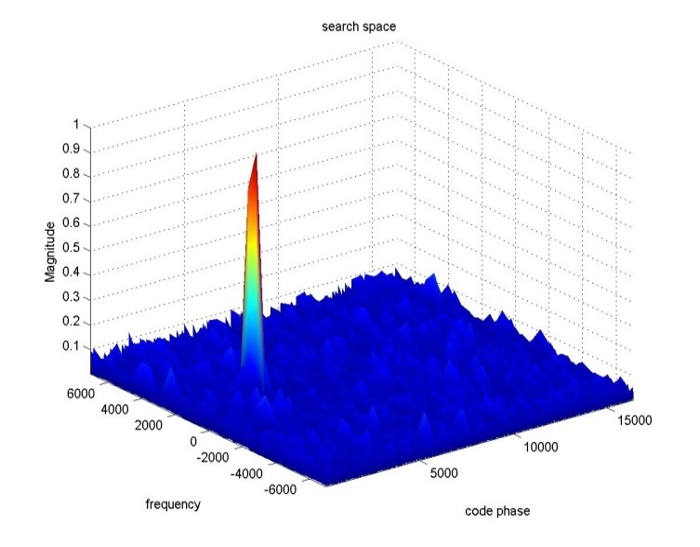

**Fig. 2 Output from conventional circular correlation algorithm.**



**Fig. 3 Spectrum of the local code.**

When acquisition is performed on 1ms data to acquire one satellite, a total of 29 circulations are needed. Each circulation includes two DFT and one IDFT, the total operations of each circulation can be calculated. In terms of DSP theory, calculation of n length DFT needs  multiplies and  adds.

In comparison with conventional circular correlation algorithm, the computational burden can be cut to two third in the improved circular correlation algorithm. The equation is as follows:

 (7)

In our implementation, improved circular correlation algorithm output of a visible satellite is shown as follow (see Fig. 4):

And the execution time of the method of acquiring one satellite is 0.25 s. The improved algorithm acquiring 32 satellites needs 7 seconds. In comparison with the traditional algorithm, the time of acquisition decreases from 0.47 s to 0.25 s.

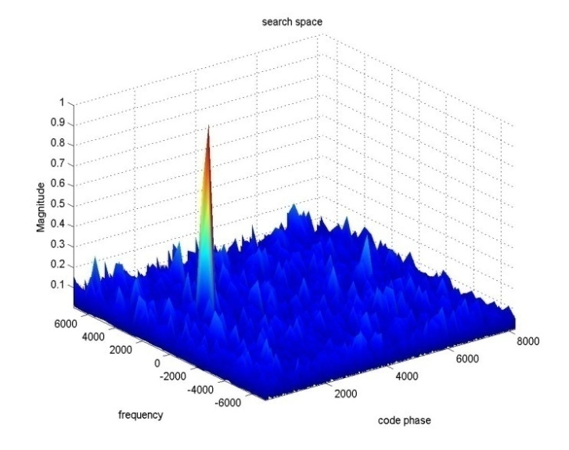

**Fig. 4 Output from improved acquisition algorithm.**

4. Fine Frequency Estimation

The frequency resolution obtained from 1ms data is about 1KHz, which is too coarse for the tracking loop [3]. Using the DFT or FFT to find fine frequency is not a suitable approach, because increasing the length of the data for acquisition will spend more time. The approach to find the fine frequency resolution is through phase relation. If the highest frequency component in 1ms data at time  is , represents the frequency component of the input signal. The initial phase  of the input can be found from the FFT outputs as:

 (8)

Where ‘Im’ and ‘Re’ represent the imaginary and real parts, respectively. Let us assume that at time , a short time after , the FFT component  of 1ms data is also the strongest component, because the input frequency will not change that rapidly during a short time. The initial phase angle of the input signal at time  and frequency component  is

 (9)

Eq. (8) and eq. (9) can be used to find the fine frequency as

 (10)

Eq. (10) provides a much finer frequency resolution than the result obtained from FFT.

5. Signal Tracking

After performing the acquisition, control is handed over to the tracking loops, which are used to refine the frequency and code phase parameters. The main purpose of tracking is to refine the carrier frequency and code phase parameters, keep track, and demodulate the navigation data [4].

A combination of code tracking loop and carrier tracking loop is used in tracking procedure. Fig. 5 shows a complete tracking loop.

**Fig. 5 Structure of a complete tracking loop.**

The carrier tracking loop is to keep track of the carrier frequency of a specific satellite. Due to navigation bit transitions, a Costas loop was used in software receiver.

The code tracking loop is to keep track of the code phase of a specific code. The code tracking loop uses a delay lock loop called an early-late tracking loop [5].

6. Results and Discussion

The performance of signal acquisition algorithm was analyzed using the real GPS IF data, which were collected by the NewStar210 GPS Signal Digitizer. The Signal Digitizer was stationary, and the intermediate frequency is 4.123968 MHz and the sampling frequency is 16.367667 MHz [6].

The execution time of acquisition decreases from 0.47 s to 0.25 s when acquiring one satellite. From Table 1 and Table 2, we can see that the results from traditional and improved acquisition have slight differences.

**Table 1 Results from traditional acquisition.**

|  |  |  |  |
| --- | --- | --- | --- |
| PRN | Frequency(Hz) | Doppler(Hz) | Code offset |
| 4 | 4.123475e+006 | -520.433 | 13793 |
| 2 | 4.1254e+006 | 1405.15 | 3919 |
| 10 | 4.12681e+006 | 2841.79 | 8317 |
| 17 | 4.12149e+006 | -2475.86 | 440 |
| 13 | 4.123296e+006 | -671.527 | 10181 |

**Table 2 Results from improved acquisition.**

|  |  |  |  |
| --- | --- | --- | --- |
| PRN | Frequency(Hz) | Doppler(Hz) | Code offset |
| 4 | 4.12347e+006 | -499.881 | 6896 |
| 2 | 4.1254e+006 | 1429.91 | 1960 |
| 10 | 4.12678e+006 | 2811.79 | 4159 |
| 17 | 4.12146e+006 | -2505.71 | 220 |
| 13 | 4.12332e+006 | -651.225 | 5090 |



**Fig. 6 Tracking result for doppler-frequency offset with costas loop.**



**Fig. 7 Navigation data demodulated by tracking loop.**

After performing improved acquisition, these values in Table 2 are passed into tracking loop. With these values, the tracking loop can keep track and demodulate the navigation data correctly, which are shown in Fig. 6 and Fig. 7.

7. Conclusions

By comparison with traditional algorithm, improved algorithm has three advantages, which are as follows:

* The computational burden of DFT and IDFT can be cut to two third in the improved acquisition.
* The size of two-dimension search space decreases from  to , which can decrease the search time.
* The improved algorithm has good acquisition performance and these values obtained from it can initialize the tracking loop.

In conclusion, the speed of improved acquisition doubles that of traditional acquisition. The traditional algorithm can be instead of improved algorithm.

First, we could improve acquisition method to increase the GPS receiver sensibility. Second, new acquisition algorithm needs to be developed for future signal, such as L2 and L5.

References

1. Eason, G., Noble, B., and Sneddon, I. N. 1995. “On Certain Integrals of Lipschitz-Hankel Type Involving Products of Bessel Functions.” *Phil. Trans. Roy. Soc. London*, A247: 529 -551.
2. Krevelen, D. W. V. 1990. *Properties of Polymers*. São Paulo: Elsevier.
3. Reed, B. W., Semmens, M. J., and Cussler, E. L. 1995. “Membrane Contactors.” In *Membrane Separation Technology, Principles and Application,* edited by Noble, R. D., and Stern, S. A. Amesterdam: Elsevier.
4. Faraday, C. Forthcoming. “Protean Photography.” In *Seven Trips beyond the Asteroid Belt,* edited by Oring, J. Cape Canaveral, FL: Launch Press.
5. Fine, L. 2005. “Einstein Revisited.” *J. Chem. Educ.* 82: 1601-11. Accessed October 15, 2005. http://jchemed. chem.wisc.edu/Journal/Issues/2005/Nov/abs1601.html.
6. Young, C. A., and Jordan, T. S. 1995. “Cyanide Remediation: Current and Past Technologies.” In *Proceedings of the 10th Annual Conference on Hazardous Waste Resource,* 104-29.
7. Mackel, H. 2004. “Capturing the Spectra of Silicon Solar Cells.” Ph.D. thesis, The Australian National University.

1. **Corresponding author:** Full Name, Academic title, degree, research fields: telecommunications, radio spectrum management, cognitive radio, signal processing. E-mail: …