A Survey-Based Study of Artificial Intelligence Literacy Among Chinese University Students

DAVID PUBLISHING

D

ZHOU Xintong, DONG Qiyang, ZHU Leyang, ZHI Yuying

University of Shanghai for Science and Technology, Shanghai, China

[1]

As artificial intelligence (AI) technologies continue to transform education, fostering AI literacy among university students has become increasingly important. Despite growing interest in AI-related education, empirical research on university students’ AI literacy, particularly in the Chinese higher education context, remains limited. This study aims to examine the current state of AI literacy among Chinese university students through a survey-based approach. Grounded in five dimensions—AI knowledge, skills, ethics, thinking, and collaboration—the study surveyed 83 undergraduate students. The results indicate that while students possess a foundational level of AI literacy, there is considerable room for development. Positive correlations among all five dimensions suggest a mutually reinforcing relationship in students’ AI engagement. Specifically, students with greater awareness of AI applications tend to demonstrate stronger collaborative learning abilities, and those who recognize the interdisciplinary nature of AI show greater attentiveness to its advancements. These findings underscore the need for more integrated and dimensionally balanced AI literacy education in higher education contexts.

*Keywords:* artificial intelligence literacy, artificial intelligence, university student, education technology

Introduction

With the rapid development of artificial intelligence (AI) technology, its application in various fields is increasingly extensive, which has a profound impact on education. AI not only changes the way of teaching and learning, but also presents new challenges and opportunities in education. In this context, AI literacy has become an important research field, which involves individual understanding of AI technology, application ability, ethical cognition, critical thinking, and collaboration ability.

In recent years, the popularity and application of AI technology have been accelerating worldwide. The wide application of AI technology not only requires professional technicians to have deep AI knowledge and skills, but also requires the general public to have a certain AI literacy in order to better understand and adapt to the changes brought about by AI technology. In the stage of higher education, university students, will become the backbone of the future society. Their AI literacy will directly affect their future career development and social participation ability. However, there is relatively little research on AI literacy among university students, especially in the context of Chinese universities. Understanding the current situation of Chinese university students’ AI literacy is of great significance for the formulation of educational policies, curriculum design, and future vocational training. Against this background, the current study proposed two research questions:

1. Research question 1 (RQ1): What is the current status of AI literacy of Chinese university students?

2. Research question 2 (RQ2): Is there any relationship among the dimensions of AI literacy? If yes, in what way?

Previous Studies on AI literacy

Wu, Li, Chen, Jiang, and Sun’s (2024) study put forward the composition of university students’ AI literacy, the goal and vision of cultivation, as well as the carrier, action, and strategy of cultivation. It considers that university students’ AI literacy is an organic whole, composed of systematic knowledge, constructive ability, creative value, and humanistic ethics, in which knowledge, ability, value, and ethics serve as the foundation.

Zhou, Xu, and Cai (2024) aimed to delve into the current status of AI literacy among high education students and its correlation with practical application, attitude, and interest. They explored the feasibility and measures for high education institutes to cultivate students’ AI literacy in the era of AI, and provided empirical support and theoretical guidance for advancing AI literacy education. Zhou et al.’s (2024) study presents a targeted scale for assessing the AI literacy level of high education students and examines the factors influencing AI literacy. It lays the groundwork for future in-depth exploration of the correlation between practical application of AI and theoretical learning, as well as developing a tailored educational training framework.

Dimensions in AI Literacy

In order to systematically cultivate students’ AI literacy, it is essential to develop a scientific AI literacy framework. The AI Literacy Framework provides educators with clear guidelines to help them design content and activities from different dimensions, ensuring that students are not only equipped with technical knowledge, but also properly understand and respond to the societal challenges posed by AI. Through this framework, students will not only master the basic principles and applications of AI technology, but also develop into members of society who can use AI innovatively, critically, and responsibly.

AI literacy is a multi-dimensional concept that involves the mastery of knowledge, the application of skills, and the understanding of ethical and social implications. Different education systems may have different understanding and evaluation standards, and lack a unified evaluation scale. The AI literacy framework provides educators with an actionable assessment system through clear criteria and assessment tools. This allows educators to objectively measure students’ progress in various dimensions of AI literacy and adjust teaching strategies based on the assessment results, thus achieving personalized and precise educational training.

AI literacy is not only the domain of computer science, it also has important implications for students in all disciplines. For example, students in fields, such as literature, sociology, and medicine also are required to have a certain level of AI literacy in order to better understand and respond to the changes brought by AI technology. Cai and Yu (2024) pointed out that an integrated AI literacy framework of the core elements of interdisciplinary education promotes the in-depth development of AI literacy education in the field of scientific research. AI literacy frameworks can facilitate interdisciplinary collaboration and instructional design. Through this interdisciplinary study, students are able to better understand the needs of different fields and are able to use AI technology to provide innovative solutions to real-world complex problems.

Understanding the multidimensional nature of AI literacy can help us take a more holistic view of this rapidly evolving field. Each of these dimensions was introduced in the following paragraphs, from understanding AI concepts to technical capabilities, and how together they make up our overall understanding of AI.

The first dimension of AI is knowledge, which refers to the understanding of what AI means, and other basic relevant concepts and terms such as machine learning and deep learning. Li (2023) pointed out that AI knowledge shows its status as an important cornerstone. Therefore, AI knowledge is fundamental to using and evaluating AI tools and helps users understand the capabilities and limitations of AI technology.

The second dimension of AI is skill, which means that one should be able to apply theoretical knowledge to identify, evaluate, apply, and integrate AI technologies, tools, and resources, to achieve specific goals and solve practical problems in digital living, learning, working, and social scenarios (Yin, 2024). AI knowledge focuses on theory, while AI skill focuses on practice, which improves work efficiency and innovation ability.

Ethic is the basis of any other dimensions in AI literacy, reminding people of the social responsibility one must assume in applying these skills, as the application of AI technology could have a profound impact on society. Currently, there have been principles that should be complied by AI users, such as “Clear the subject status of human” and “Respect the public interest and intellectual property rights” (Su et al., 2024). Internationally, Recommendation on the Ethics of Artificial Intelligence from UNESCO was adopted in 2021, in order to guide the construction of the necessary legal framework to ensure the healthy development of AI.

AI thinking refers to how AI influences the way humans approach problems and decision-making, and stresses the thinking mode and methodology that individuals should have in the process of using AI technology and adapting to AI social environment (Yin, 2024), including how to analyze data, identify patterns, and make decisions. It also emphasizes the importance of interdisciplinary thinking.

AI coordination is another dimension, which emphasizes how humans and machines complement and collaborate to increase efficiency and creativity. The key point is that the ability of machines to process large amounts of data and information allows humans to focus on creative thinking. Shi and Mao (2024) pointed out in their paper that both undergraduates and the employed should be equipped with ability of human-machine collaboration. So, university students with AI coordination capacity can process information more efficiently and better handle future developments in society.

Table 1

*Dimensions in AI literacy*

|  |  |  |
| --- | --- | --- |
| **Dimension** | **Identification** | **Examples** |
| Knowledge | The understanding of what AI means, and other basic relevant concepts and terms | AI basic principles and core technologies; fundamentals of machine learning |
| Skill | The ability to perform AI for different purposes | Be familiar with basic AI tools |
| Ethic | The understanding of AI ethics, privacy protection, and the technology's impact on society | Ethical issues of AI technology; data privacy and security |
| Thinking | The thinking model to understand and utilize AI technology | Adopt a systematic approach to problem solving |
| Coordination | Complementarity and collaboration between human and machines | Significantly improved efficiency and accuracy through human-machine collaboration |

Research by Cai, Zhang, Yu, and Wang (2024) suggested that existing frameworks of AI literacy from previous studies can be roughly categorized into four groups, according to applicable subjects: K-12 (kindergarten through 12th grade) students, university students, unprofessional employees and unprofessional public. These frameworks therefore have different emphases. Some traditional technology-oriented frameworks mainly focus on technical knowledge and application capabilities, while some emphasizes interdisciplinary cooperation and advocates comprehensive learning. Table 1 above is the AI literacy framework used in this study.

Methods

## Research Subjects

This study involved 83 university students enrolled at a comprehensive university in China. Participants were recruited from different academic years and a variety of majors, including both humanities and sciences, to ensure diversity in educational background and learning experience. No restrictions were placed on students’ fields of study, allowing for a broad representation of disciplines. Demographic information, such as participants’ year of study and major was collected to facilitate subgroup analyses. This sampling approach supports the exploration of potential variations in AI literacy across academic levels and disciplines.

## Research Questionnaire

This study adopted the *National College Students’ Artificial Intelligence Literacy Competency Test Scale (Final Version)* developed by Li (2023),as part of the project *Research on the Development of Artificial Intelligence Literacy Evaluation Tools for College Students*. The questionnaire is designed to assess university students’ AI literacy across five core dimensions: AI knowledge, AI skills, AI ethics, AI thinking, and AI collaboration.

In addition to three initial items collecting participants’ demographic information, the questionnaire comprises four main multi-part questions. The first part assesses AI Ethics through three components: individuals’ awareness of ethical issues, their attitudes toward AI, and their sense of responsibility in AI-related contexts. The second part evaluates AI knowledge and AI skills, encompassing students’ understanding of AI concepts and their ability to apply them in practice. The third part targets AI thinking, which includes computational thinking, data literacy, critical thinking, and programming-related cognitive skills. The fourth part measures AI collaboration, focusing on both teamwork and human–AI co-innovation.

The instrument is based on students’ self-assessment, using a five-point Likert scale, where responses range from 1 (“Very inconsistent with one’s own situation”) to 5 (“Very consistent with one’s own situation”). The collected data were subjected to descriptive and inferential statistical analyses to examine the distribution of scores across dimensions and to explore interrelationships among them. This design enables a comprehensive diagnosis of students’ AI literacy profiles and their internal associations.

Results and Discussions

This section presents the findings of the study in relation to the two research questions. The data were obtained from a self-report questionnaire measuring five dimensions of AI literacy: AI knowledge, AI skills, AI ethics, AI thinking, and AI collaboration. Participants rated each item using a five-point Likert scale, ranging from 1 (“Very inconsistent with one’s own situation”) to 5 (“Very consistent with one’s own situation”).

## Descriptive Analysis of Chinese University Students’ AI Literacy

Before conducting analysis of the questionnaire data, necessary preconditioning work was first carried out. A total of 83 questionnaires were collected after invalid questionnaires were screened out one by one. By filtering out those unanswered or obviously arbitrary responses, the quality of the remaining questionnaire data was ensured to be more reliable.

Descriptive statistical analysis is taken as the primary step, providing researchers with a clear entry point that can reveal the core characteristics of the data set and lay the foundation for subsequent analysis. For example, by calculating the mean of a series of questions about AI knowledge, it can indicate the level of students’ understanding of artificial intelligence. If the mean is closer to 5, it indicates that the majority of students have a high level of awareness of artificial intelligence; on the contrary, if the mean is close to 1, it indicates that students generally lack basic understanding of artificial intelligence.

Regarding AI skill and AI coordination, standard deviation reveals the differences in students’ frequency of their use of AI. If the standard deviation is large, it means that there are significant individual differences in students' mastery and use of artificial intelligence tools, with some students frequently using them while others hardly use them.

As for the sense of responsibility towards AI, which involves sense, attitude and ethical problems, the bigger the mean is, the less responsible the students are to today’s artificial intelligence. This is a very critical part because part of the students may be responsible for the future development of AI-related business. Only by understanding the users’ responsibility can they become more responsible developers in the future. Actually, everyone in the digital society has a common task which is to consider the relationship between human beings and AI. Whatever occupation students will choose in the job market, as developers or users, they will inevitably keep close connection to AI-dependent products. Therefore, they are ought to carefully consider the relationship between AI and themselves, so that they are able to protect themselves and make contributions to the future AI industry.

After analyzing the responsibility towards AI products, it is necessarily essential to rethink the human-machine collaborative innovation. Thanks to the boom of AI industry, many opportunities appear and the connection between human and machines is unprecedentedly tight. Making full use of AI becomes a task especially for university students and those who are capable of suing AI will out stand in face of the job market. In brief, the development of AI provides both effectiveness and efficiency to many work and getting well along with AI will definitely become an essential task sooner or later. The earlier students can master AI-related skills, the better they will complete their work.

## Correlational Analysis among Dimensions of AI Literacy

On the basis of statistical analysis, this paper further explores the internal relationship between various dimensions of university students' artificial intelligence literacy and the correlation between these dimensions and students’ background factors through correlation coefficient analysis. Correlation coefficient analysis can help us understand the strength and direction of the linear relationship between different variables, so as to provide a clearer direction for further research.

By calculating the Pearson correlation coefficient, we analyzed the relationship between the following key variables. Based on the data obtained from the item of AI ethic in the questionnaire, “Be able to perceive the application of artificial intelligence in life, and how it changes production and life”, and the item of AI cooperation. “Be able to take the initiative to cooperate with others and take responsibility in the artificial intelligence environment”, the relationship between participants’ perception of the application of AI in their lives and their ability to learn cooperatively in an AI environment was analyzed.

The statistic indicated a significant positive correlation between participants’ perception of AI applications and their cooperative learning abilities (*r* = 0.77, *p* < 0.01). Particularly, the mean score for the perception of AI applications and its impact on production and life was 4.12 (*sd* = 0.88), while the mean score for the ability to actively cooperate with others to learn and take responsibility in an AI environment was 3.96 (*sd* = 0.93).

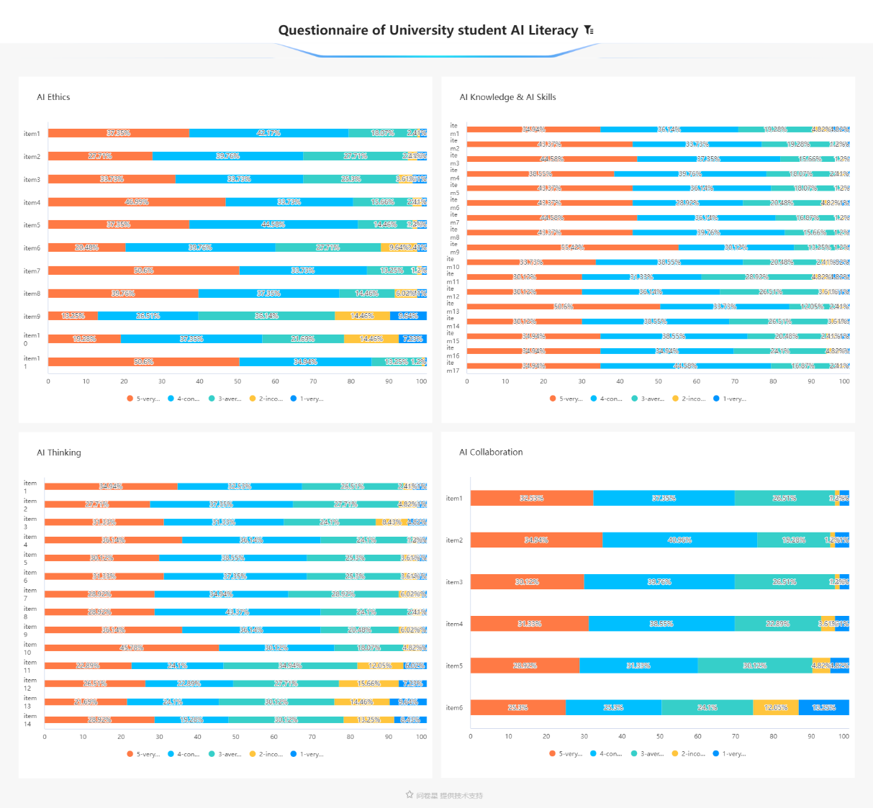

*Figure 1.* Bar chart of university student AI literacy survey results.

This result suggests that university students who are able to effectively perceive the application of AI in their lives also tend to exhibit strong cooperative learning abilities and responsibility. This may reflect that a student’s understanding and cognition of AI can promote their interaction and collaboration in a team environment, thus improving learning effectiveness and responsibility (see Figure 1).

On the other hand, the data of the item of AI ethics that “Be able to actively pay attention to the frontier information of artificial intelligence, understand and experience new artificial intelligence products” and the item of AI knowledge that “Understands that the discipline of artificial intelligence is an interdisciplinary discipline integrating computer science, psychology, philosophy, and other disciplines”, aims to explore the relationship between the understanding of artificial intelligence and the active attention to the frontier information of artificial intelligence.

The results of the correlation analysis indicate a significant positive correlation between these two variables. The mean score for understanding that AI is an interdisciplinary field integrating computer science, psychology, philosophy, and other disciplines is 4.14 (*sd* = 0.94). The mean score for actively paying attention to cutting-edge AI information and experiencing new AI products is 3.88 (*sd* = 0.93). The correlation coefficient is *r* = 0.68, with *p* < 0.01.

This result indicates that respondents have a high level of cognition on the multidisciplinary integration characteristics of artificial intelligence, and this level of cognition is closely related to their ability to actively pay attention to the frontier information of artificial intelligence. Specifically, understanding the subject background of artificial intelligence can promote individuals’ attention to and exploration of relevant information, which is of great significance for promoting the popularization and application of knowledge in the field of artificial intelligence.

This significant positive correlation suggests that respondents have a high level of cognition on the interdisciplinary nature of AI, which is closely related to their ability to actively engage with cutting-edge AI information. Understanding the interdisciplinary background of AI can significantly promote individuals’ attention to and exploration of relevant information. With the evolution and popularization of AI technology, this finding is essential for promoting the dissemination and application of knowledge in the field of AI. It not only reflects the positive impact of cognition on behavior, but also reveals the potential value of interdisciplinary teaching methods in university education.

Although correlation analysis provides us with valuable insights, this method can only reveal linear relationships between variables and differences between groups, and cannot explain inner causation. Therefore, further studies can use more advanced statistical methods, such as regression analysis to further explore the causal relationship between these variables.

In addition, considering the limited sample size (only 83 questionnaires), further studies can expand the sample size to improve the generalizability and reliability of the results. At the same time, the combination of qualitative research methods (such as interviews or focus group discussions) can provide a deeper understanding of the cognitive process and influencing factors of students’ AI literacy, and provide a richer perspective for a comprehensive understanding of university students’ AI literacy.

Conclusion

This study conducted a comprehensive analysis of university students’ AI literacy from five dimensions of knowledge, skills, ethics, thinking, and collaboration through a questionnaire survey. The results show that university students have a certain foundation in all aspects of artificial intelligence literacy, but there is still room for improvement. In addition, there is a positive correlation among all dimensions, indicating that the accumulation of knowledge, the application of skills, ethical cognition, thinking ability, and collaboration ability promote each other, and together constitute the overall framework of university students’ AI literacy. These findings provide important references for educators, suggesting that the combination of knowledge and practice should be emphasized in curriculum design, ethical education should be strengthened, students’ critical thinking and innovative thinking should be cultivated, and team cooperation ability should be enhanced, so as to comprehensively improve the artificial intelligence literacy of university students.

References

Cai, Y., Zhang, J., Yu, C., & Wang, J. (2024). Artificial intelligence literacy in the digital intelligence era: Connotation, framework, and implementation pathways. *Journal of Library Science in China, 50*(4), 71-84.

Cai, Y., & Yu, C. (2024). Transforming research paradigms through AI: A study on artificial intelligence literacy and education strategies from an interdisciplinary perspective. *Library Development, 43*(11).

Li, J. (2023). *Research on evaluation methods of artificial intelligence literacy of university students* (DOI: 10.26969/d.cnki.gbydu.2023.001497) [Master’s thesis, Beijing University of Posts and Telecommunications]. China National Knowledge Infrastructure.

Shi, M., & Mao, Y. (2024). Concept, framework and education for artificial intelligence literacy. *Library Tribune, 44*(11), 90-100.

Su, W., Guo, H., Lu, Z., Pan, Y., & Liu, G. (2024). Construction and effectiveness verification of evaluation index system of artificial intelligence literacy of Chinese university students. *Library Development*, CNKI. Retrieved July 1, 2024, from https://link.cnki.net/urlid/23.1331.G2.20240624.1801.004

Wu, F., Li, Y., Chen, J., Jiang, Q., & Sun, L. (2024). Red book on artificial intelligence literacy of university students (2024 Edition). *Journal of Science, Technology and Education Studies, 4*(2), 71-96.

Yin, K. (2024). Artificial intelligence literacy: Background, concept definition and components. *Library & Information*, *217*(30), 60-68.

Zhou, Q., Xu, Y., & Cai, Y. (2024). An examination of AI literacy among university students: Current status and multifaceted influencing factors. *Information & Knowledge, 41*(3), 38-48.

1. ZHOU Xintong, undergraduate, College of Foreign Languages, University of Shanghai for Science and Technology, Shanghai, China.

   DONG Qiyang, undergraduate, College of Foreign Languages, University of Shanghai for Science and Technology, Shanghai, China.

   ZHU Leyang, undergraduate, College of Foreign Languages, University of Shanghai for Science and Technology, Shanghai, China.

   ZHI Yuying (Corresponding author), Ph.D., lecturer, College of Foreign Languages, University of Shanghai for Science and Technology, Shanghai, China.